

**March Good News 2024**

**Our ministry vision for the Virginia Annual Conference is *“to be disciples of Jesus Christ who are lifelong learners, who influence others to serve.”***



**From Pastor Adam**

*“Lions and Lambs”*

*“For everything there is a season, and a time for every matter under heaven…”* (Ecclesiates 3:1)

It has often been said that March “comes in like a lion, but goes out like a lamb.” The March

weather can be fierce at first, but as the days grow milder and milder throughout the month,

Spring comes into view, and our hopeful visions of the warmth of those early spring days begins

to take shape. While I prefer the warmth of spring and summer, I have come to appreciate the gift of all the seasons and the variety and splendor they bring to our lives. The change in the weather is a wonderful metaphor for life. There will be seasons (moments of trial, moments of joy) that we appreciate more than others. Yet each season comes as a gift – teaching us, shaping us, and forming people of resilience and grace. The writer of Ecclesiastes suggest that there is a “temporary-ness” to each season. This means that hard times do not ultimately last. It also means that days of joy and peace are to be celebrated with all the more gusto. We face the future boldlyknowing that God is with us, and God’s care and loving-kindness never fail...no matter what the season.

God bless you my friends! Adam



Join us for *Maundy Thursday* worship service on Thursday, March 28, 2024, at 5:00 p.m. Holy Communion will be served.

Circle News****

The Wesleyan Group …will meet on Monday, March 11, at 7:00 p.m., at the home of Linda Jessen.

The Merry Marthas Circle will meet on Thursday, March 28, at 10:30 a.m., at church. Program TBA. Out to lunch afterward.

~*Judy Robertson*



**The choir** will be singing on Sundays, March 17th and 31st, and will be rehearsing

at 10 AM. We will sing familiar hymns so please come join us!

*~Heather Wilson*, Director of Music

*Mission Moment*

For the months of January and February the Park View Mission cart contained 74lbs. of food. The food we collected was for emergency bags for our neighbors who are homeless, transient, or have no permanent address. The need increases more in the winter months. Park View Mission is grateful for our monthly donation to help meet the needs of these neighbors. Thank you for your faithful support of Park View Mission.

For the month of March we will continue to collect canned food with pop- tops to be used in emergency bags. We will also collect body wash and shampoo for the mission’s hygiene room.

~*Linda Jessen & Mission Committee*

**Food Cart: March**

Pop-top cans of meats, soups, pasta dishes, vegetables, shampoo, and body wash.

*No* ***“baked goods”*** *!* *Place donations in the grocery cart, located in the Commons*.

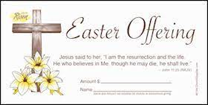**Easter Offering**

Our goal to reach will be $5,000 for maintenance expenses for sanctuary heating, fellowship hall roof leakage, and Prayer Garden updating (area outside of Commons area). 10% of this offering will go to Miriam's House.



Daylight Saving Time begins on ***Sunday, March 10, 2024***. Remember to SPRING AHEAD 1 (ONE) hour before bedtime on Saturday, March 9th.

**Christmas Offering**

We collected $4,865.00. Thank you so much for supporting Chestnut Hill.

**HumanKind**

We collected 86 items for our Mitten Trunk. We appreciate your generosity and support of this ministry. Next year we are looking at collecting used/new coats. ~*Pat Short*



*Gifts & Memorials*

In Memory Of:

*Julius L. “Bear” Tolley, Sr.*

Given by: Chet & Mary Walker, Darryl & Danny Hudnall

*Barbara LeFew*

Given by: David & Eleanor Maxham, Wilton & Kitty Burgess





***In Sympathy***

Chestnut Hill United Methodist Church extends Christian love and sympathy to the family of *Julius Lee “Bear”Tolley*, Sr., and especially to his daughter-in-law, Brenda Tolley. Mr. Tolley passed away on January 11, 2024.

To the family of *Barbara S. LeFew* and especially to her sons, Tad and Kevin. Mrs. LeFew passed away on February 3, 2024.

Andto the family of *Bill Underwood*, and especially to his wife, Jody, and children, Rebecca, Sara, and William. Mr. Underwood passed away on February 5, 2024.



*I would like to thank everyone*  for your love, cards, calls, food, and many prayers that I have received during my illness. Fred and I are hoping to be back in church on or before Easter.

~*Sue Norvelle*

**March Birthdays**

1 Christine Donald

4 Edward Morton

5 Kitty Burgess

Kyle Childress

6 Rev. Adam White

11 Bryan Tiller

12 Teresa Bell

20 Meggan Saul

21 Ryan Bell

22 Addison Jay

Pat Wiley, Jr.

25 Sandra Kinzer

26 Marsha Burks

Steve Coleman

29 William Underwood, Jr.

30 Vickie Busic

Jason Witt

31 Wendy Dalton



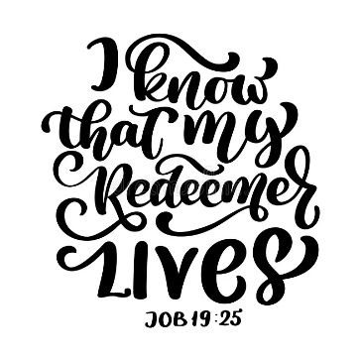

**March 2024**

|  |  |  |  |  |  |  |
| --- | --- | --- | --- | --- | --- | --- |
| **Sunday** | **Monday** | **Tuesday** | **Wednesday** | **Thursday** | **Friday** | **Saturday** |
|  | | | | | **1**  10:00am Homeschool  3:30pm Homeschool Yearbook meeting | **2** |
| **3 *Third Sunday in Lent***  9:30am Sunday School  10:30am Worship | **4** | **5** | **6** | **7** | **8**  10:00am Homeschool  5:30pm Earring Class | **9** |
| **10 *Fourth Sunday in Lent***  ***Daylight Saving Time begins***  9:30am Sunday School  10:30am Worship | **11**  7:00pm Wesleyan Group @ Jessen Home | **12**  7:00pm Homeschool Game Night | **13** | **14** | **15**  ***Church Office Closed*** | **16** |
| **17 *Fifth Sunday in Lent***  ***St. Patrick’s Day***  9:30am Sunday School  10:00am Choir  10:30am Worship | **18** | **19**  Spring Begins in the US - Wednesday, March 20, 2024 | **20** | **21** | **22**  10:00am Homeschool  3:30pm Homeschool Preteen Game Night | **23** |
| **24** ***Palm Sunday***  9:30am Sunday School  10:30am Worship | **25** | **26** | holy week clip art 10 free Cliparts | Download images on Clipground 2023**27** | **28 *Maundy Thursday***  10:30am Merry Marthas  5:00pm  Maundy Thursday Worship Service | **29 *Good***  ***Friday***  10:00am Homeschool | **30** |
| **31** ***Easter Sunday***  9:30am Sunday School  10:00 am Choir  10:30am Worship | 251,115 Religious Easter Images, Stock Photos, 3D objects, & Vectors |  Shutterstock | | | | | |





1 Pat Short

2 Nancy Lee

Emily V.

Fernandez

3 Michael McGlothlin

6 Kirsten Bell

Tim Crist

Dennis Tolley

7 Kenny Busic

Cheryl Powell

9 Owen Stinnette

Jeremey

VandeBogart

11 Landen Glass

12 Camden Mason

14 Wade Ware

16 Burton Brooks

Terry Palazzi

Anne-Elaine Tiller

17 Suzanne

Marshall

Blake Phillips

18 Sharon

Rickmon

19 Connie Yost

20 Erin Ecklund

21 Steven Kinzer

22 C.O. Bell

25 Frankie

Hardwick

28 Jacqueline Busic

Cheryl Thomas

29 Wes Robbins

Ricky Smith

31 Robert Baunach

**2022**

**March 2022**

**Those Who Serve ~ March**

**GREETERS:**

March 3 ~ *Mary Walker*

March 10 ~ *Dan Robertson*

March 17 *~ Betty Taylor*

March 24 *~ Judy Robertson*

**Our Church Financial Picture**

Through the end of January 2024

General Operating Funds:

Needed to meet our 2024 Budget $ 197,677

Needed to meet our budget to date $ 16,473

Actual receipts to date $ 10,456

Shortage to meet budget to date $ 6,017

Actual expenditures to date $ 11,911

Shortage to meet expenses to date $- 1,455

Joy In Missions Funds

Our Giving Goal for 2024 $ 8,600

Needed to meet our goal to date $ 717

Actual receipts to date $ 905

Special Offerings* (not budgeted):

Received to date $ 240

Dispersed to date $ 0

*Christmas, Easter, Annual Conference,

World Communion, etc.

**2024 Joy In Mission Donations**

To date, the following amounts have

been paid to the missions indicated.

Budget Spent

1. Missionary Covenant Relationship

$1,000 $ 0

2. Park View Mission, Food for Families

$3,000 $ 0

3. Society of St. Andrew $1,000 $ 0

4. Blue Ridge Area Food Bank $1,000 $ 0

5. Daily Bread $ 500 $ 0

6. Good Neighbor $ 500 $ 0

7. Habitat for Humanity $ 500 $ 0

8.. UMCOR-Non-Administrative $ 500 $ 0

9. Undesignated $ 600 $ 0

10. Meals on Wheels (Souper Bowl) $ 0

Thank you for your generosity.

**GOOD NEWS** is

published monthly for members and

friends of Chestnut Hill United

Methodist Church. Send articles to

the church office by the 15th of the

month. (Subject to change).

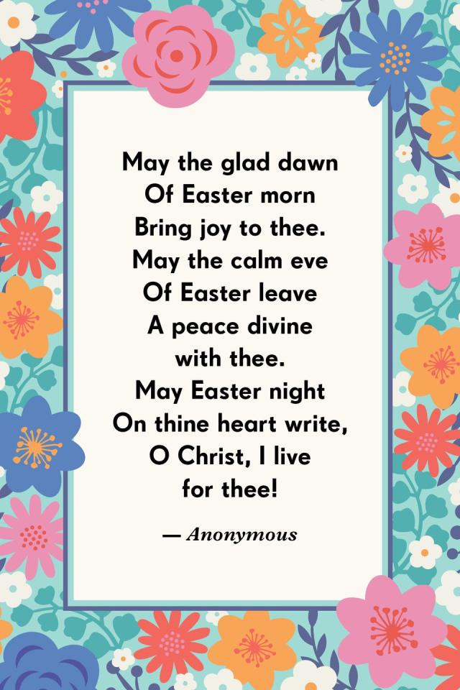



January 2022

**2022**





**April 2022**

**April 2022**

**March 2022**

*Chestnut Hill United*

*Methodist Church*

4660 Fort Avenue, Lynchburg, VA 24502

Phone Number: 434-239-8423: FAX: 434-239-7209

E-mail: [chestnuthillumc@comcast.net](mailto:chestnuthillumc@comcast.net)

On the web: www.chestnuthillumc.net

Church Office Hours

**Monday-Thursday~**9:00 am—3:30 pm

**Friday~**9:00 am-1:00 pm



***DIRECTORY OF***

***CHESTNUT HILL UNITED METHODIST CHURCH***

|  |  |  |
| --- | --- | --- |
|  | Sue Haupert-Johnson | Richmond Area Resident Bishop |
|  | Denise Bates | Mountain View District Superintendent |
|  | Adam White | Minister |
|  | Erin Long | Associate Minister |
|  | Monica Campbell | Administrative Assistant |
|  | Heather Wilson | Director of Music Ministry |
|  | Judy Martin | Bookkeeper |
|  | Judy Robertson | Lay Leader |
|  | Elizabeth Nichols | Missionary in Henry County |